Experiment No. 8
GAS SENSOR MQ-2 IN PROTEUS USING ARDUINO
Objectives
- To interface the MQ-2 gas sensor with Arduino UNO in Proteus.
- To measure the gas sensor output using the Arduino’s analog input.
- To display the sensor readings through serial communication.
- To detect gas levels based on a predefined threshold value.
Program:
#define GreenLed 13
#define Sensor A0

void setup(){
pinMode(13,OUTPUT);
pinMode(12,OUTPUT);
pinMode(A0,INPUT);
Serial.begin(9600);

}
void loop() {
int value = analogRead(A0);
Serial.print("Analogic Value coming from the sensor : ");
Serial.println(value);
delay(100);
if(value>600){
digitalWrite(13,HIGH);
}
else{
digitalWrite(13,LOW);
}
delay(20);
}
Code for MQ6 sensor:
int mq6Pin = A0; // MQ-5 analog pin connected to A0

void setup() {
Serial.begin(9600);
}

void loop() {
int sensorValue = analogRead(mq5Pin);
Serial.print("MQ5 Sensor Value: ");
Serial.println(sensorValue);
delay(1000); // 1-second delay
}
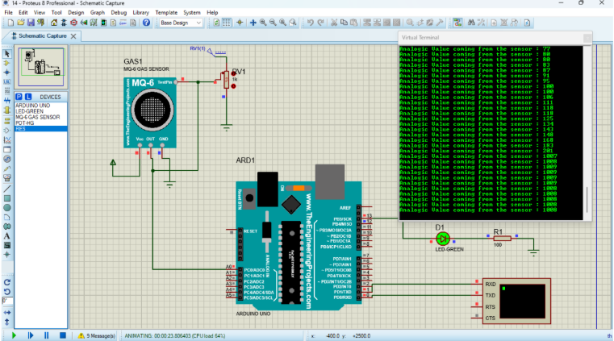
Output:

